Za sve koji vole istraživanja na Googleu još malo o šparogama na raznim jezicima

Šajeta - Šparoga Blues

http://youtu.be/XQZldkR2_J0

Bruno Krajcar - Šparoge

http://youtu.be/eAcsKy2BGAw

ŠPAROGE piza

http://youtu.be/RZ9hIwmWBhQ

o branju šparoga 17.4.2011. PLODOVI ZEMLJE autor priloga Mladen Stubljar

http://www.hrt.hr/?id=enz&tx_ttnews[cat]=205#

ESPÁRRAGOS RECETAS ESPÁRRAGOS RECETAS ESPÁRRAGOS RECETAS

RECETAS DE ESPARRAGOS

http://www.arecetas.com/esparragos/index.html

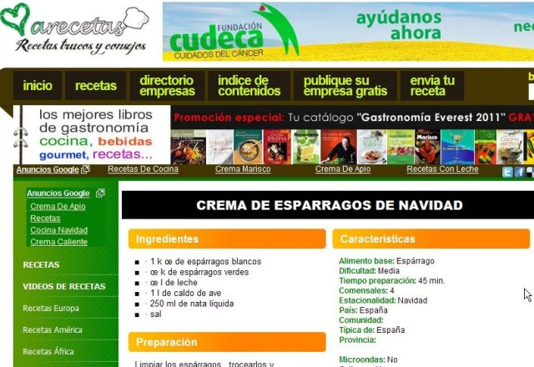

SPARRIS RECEPT SPARRIS RECEPT SPARRIS RECEPT

http://www.recept.nu/1.296225

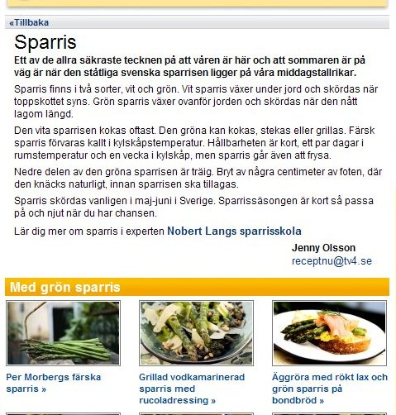

SPARGEL REZEPTE SPARGEL REZEPTE SPARGEL REZEPTE

640 Spargelrezepte http://www.spargeltreff.de/spargel/600-spargelrezepte/

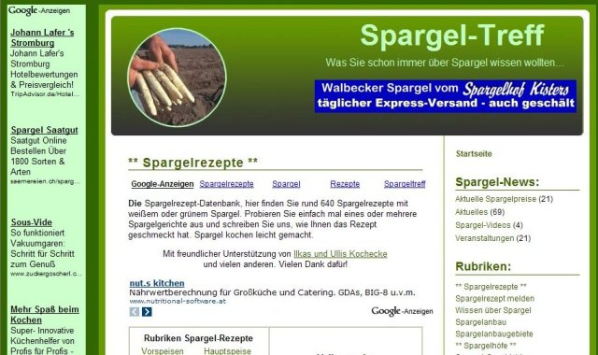

ASPARAGUS RECIPES ASPARAGUS RECIPES ASPARAGUS RECIPES

http://allrecipes.com//Recipes/everyday-cooking/seasonal/spring/asparagus/Main.aspx

Asparagus Tips
Asparagus is one of our favorite harbingers of spring. These delectable stalks with their vivid color and delicate flavor are good hot or cold, dressed up or down.
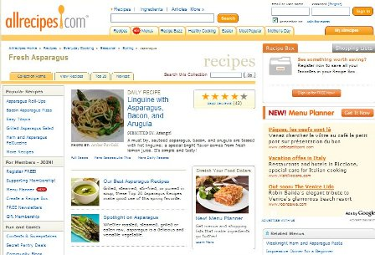

Fresh Asparagus Recipes - Allrecipes.com
Looking for fresh asparagus recipes? Allrecipes has more than 260 trusted fresh asparagus recipes complete with ratings, reviews and cooking tips.
http://www.youtube.com/watch?v=aGw_gs8UaeI

Making Hollandaise Sauce

Blender Hollandaise Sauce

http://allrecipes.com//Recipe/blender-hollandaise-sauce/Detail.aspx

http://www.food.com/recipes/asparagus

Asparagus Recipes search all 2694 recipes
Turn traditional asparagus into a crowd-pleaser by baking, roasting and sautéing your way to irresistible starters and sides for any occasion.
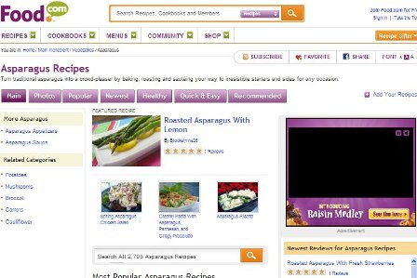
Read more: http://www.food.com/recipes/asparagus#ixzz1IOBfUWno

Asparagus With Warm Tomato Vinagrette http://www.food.com/recipe/asparagus-with-warm-tomato-vinagrette-450247

Shrimp & Asparagus Risotto - (The Olive Garden) - Official
By Starfire (aka Wendy) on July 06, 2007
Read more: http://www.food.com/recipe/shrimp-asparagus-risotto-the-olive-garden-official-239052#ixzz1IOGSI0yL

Ingredients:
Servings:
6
- 18 shrimp, shelled and deveined
- 8 cups chicken broth
- 2 tablespoons extra virgin olive oil (colaviata or or your choice)
- 1/2 cup dry white wine
- 1/2 cup butter
- 1 1/2 cups parmesan cheese
- salt & pepper
- 1/2 lb asparagus spear, fresh stemmed and cut into 1-inch pieces
- 1 cup tomato, chopped
- 1/2 cup yellow onion
- 2 cups arborio rice
- fresh parsley, chopped
Change Measurements: US | Metric

Directions:
Prep Time: 8 mins
Total Time: 33 mins
- 1 SIMMER: chicken broth on low heat until needed.
- 2 HEAT: oil over medium heat.
- 3 Add onions and cook for 3 minutes, or until translucent.
- 4 Stir in rice and cook for 1 minute, then add white wine.
- 5 Add ½ of broth and stir until completely absorbed.
- 6 Repeat until 4 cups of broth have been added.
- 7 Stir the risotto frequently to prevent sticking.
- 8 ADD: asparagus and shrimp to the remaining broth and cook for about 2 minutes, or until shrimp is pink.
- 9 Remove asaparagus and shrimp from the broth and then add them to the risotto mixture.
- 10 Add ½ cup of the broth at a time until desired creaminess is reached (there may be broth left over).
- 11 Once the broth is absorbed, add butter, parmesan cheese and salt and pepper to taste.
- 12 Garnish with chopped tomatoes and parsley.
Read more: http://www.food.com/recipe/shrimp-asparagus-risotto-the-olive-garden-official-239052#ixzz1IOGkEVMk

Olive Garden's Shrimp & Asparagus Risotto!

http://www.youtube.com/watch?v=i_ghPTaCdE0

Wild Asparagus - how to find them

http://www.youtube.com/watch?v=7RZTo8vhyfE

Wild Asparagus - how to find them

http://www.youtube.com/watch?v=7RZTo8vhyfE

http://www.cooks.com/rec/search/0,1-0,roasted_asparagus,FF.html

http://simplyrecipes.com/recipes/asparagus/
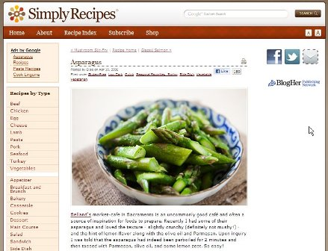

Asparagus Recipes - Recipes Using Asparagus
http://whatscookingamerica.net/Vegetables/AsparagusRecipes.htm
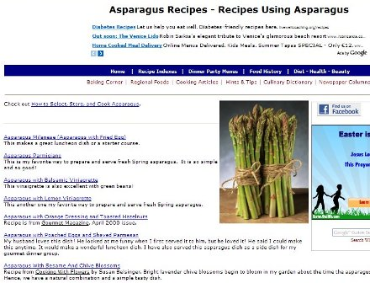

How to Cook Asparagus and Easy Asparagus Recipes
http://www.cookingnook.com/asparagus-recipes.html

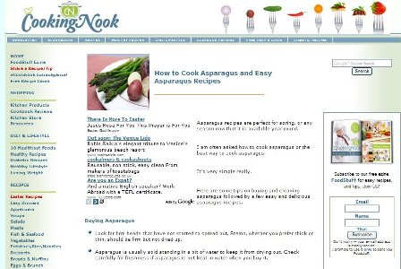

Asparagus
From Wikipedia, the free encyclopedia
http://en.wikipedia.org/wiki/Asparagus

http://urbanext.illinois.edu/veggies/asparagus.cfm

Asparagus

http://urbanext.illinois.edu/veggies/index.cfm

http://www.whfoods.com/genpage.php?tname=foodspice&dbid=12
What's New and Beneficial about Asparagus

http://www.bbc.co.uk/gardening/basics/techniques/growfruitandveg_growingasparagus1.shtml
- About asparagus
- What to do
- Watch video
- Five to try

Growing asparagus

http://www.foodnetwork.com/topics/asparagus/index.html

100 Asparagus Recipes
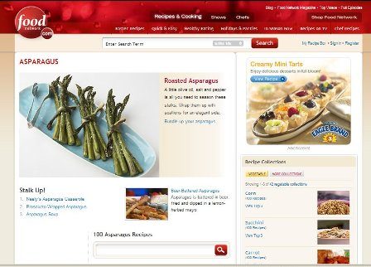

http://www.foodnetwork.com/recipe-collections/zucchini/index.html

Zucchini

(100 Recipes)

RECETTES ASPERGES RECETTES ASPERGES RECETTES ASPERGES

Recettes aux asperges
http://www.epicurien.be/recettes/fruits-legumes/asperges/recette-asperge.asp

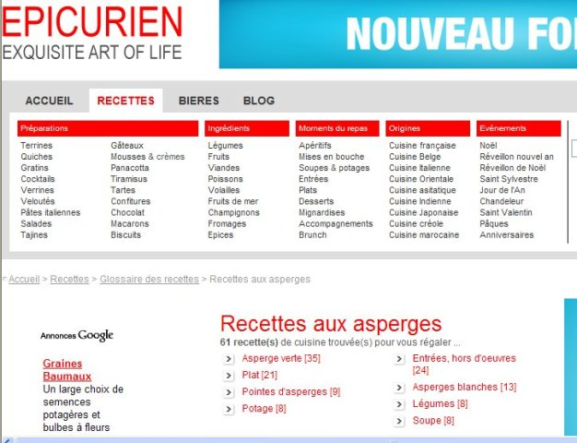

Triez les recettes de Asperges
http://www.recettesdecuisine.tv/recette-i9-f5/asperges/recette+asperges.html

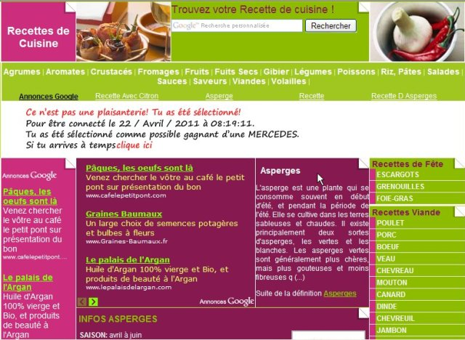

Thématique : Les asperges
http://www.recettes.qc.ca/thematiques/thematique.php?id_thematique=57

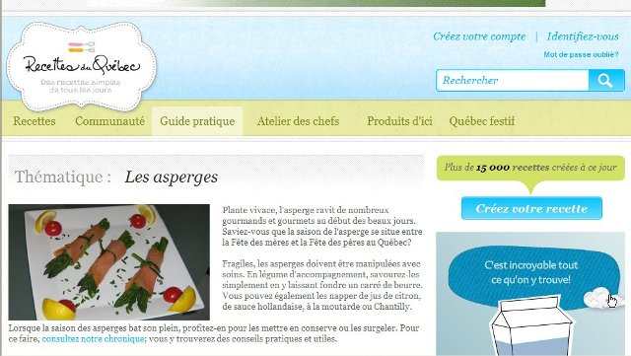

Liste de recettes sélectionnées
http://www.une-recette.com/asperges.html
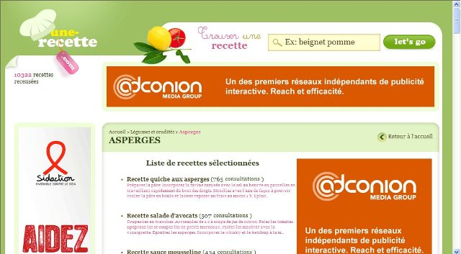

Asperges : 347 recettes
http://www.750g.com/recettes_asperges.htm

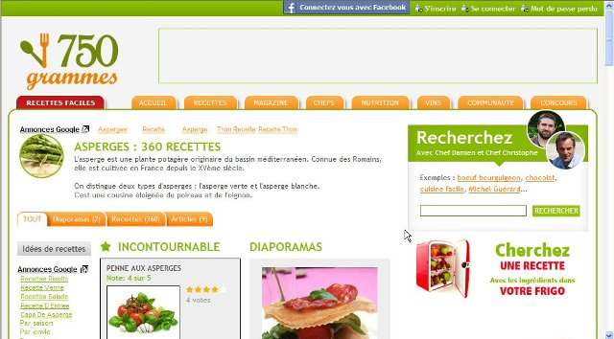

Asperges
http://www.supertoinette.com/fiche-cuisine/472/asperges.html

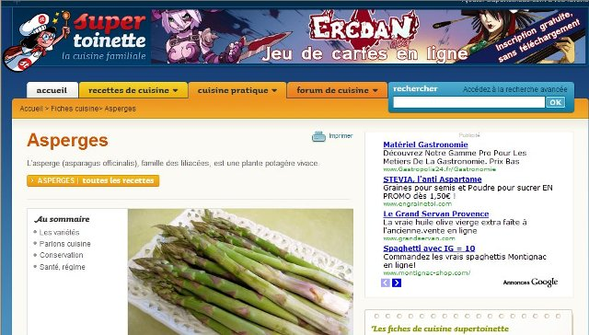

RICETTE ASPARAGI RICETTE ASPARAGI RICETTE ASPARAGI

Ricette asparagi

Asparagi Ricette Risultato: 169
http://www.cucinare.meglio.it/asparagi-p1.html

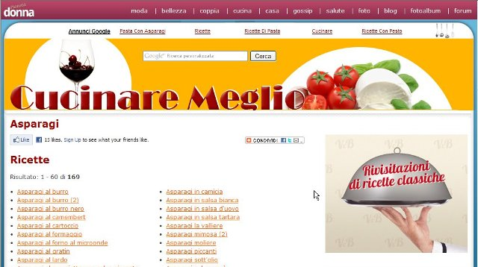

Risotto agli asparagi
http://www.youtube.com/watch?v=5Dta2tapPYE

ricetta pasta asparagi e guanciale
http://www.youtube.com/watch?v=43NuBphrNqQ

Asparagi e Pancetta
http://www.youtube.com/watch?v=qxVbnMtAcfo

http://www.frasi.net/ricette/contorni/
Asparagi Al Formaggio

Ricette con asparagi
http://www.mangiarebene.com/menu/ricette-di-stagione/ricette-con-asparagi_ID_91.htm

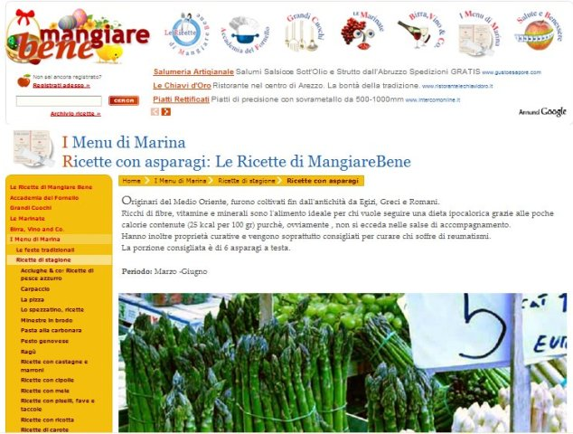

http://www.foodnetwork.com/recipe-collections/zucchini/index.html

Zucchini

(100 Recipes)

19 May, 2009

Asparagi al forno
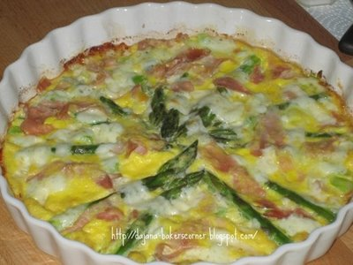
Hey, did anyone miss me?
Sorry I haven't been able to post anything in the last 10 days or so, but I've been working a lot, sleeping very little and eating very, very quickly.
Well I guess working from home and being a mom at the same time is not always the happiest combination in the world. But I'm trying to survive.
What happens in periods like this is a lot of quick dinners, usually put together with few ingredients I can find in an almost empty fridge, because even grocery shopping is a mission impossible.
I'm taking just a short break from work to write this post, and then I'll go back to my translation - can't get away from my computer, can I?
OVEN BAKED ASPARAGUS
1/2 kg asparagus
2 slices of cooked ham (prosciutto cotto)
80 g Fontina cheese
2 eggs
grated Parmigiano Reggiano
salt, butter
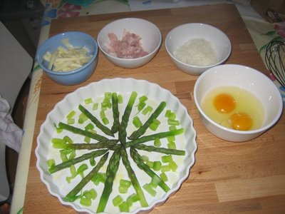
Wash the asparagus and peel the tougher outer skins. Boil them shortly till al dente.
Place drained and dried asparagus in a slightly buttered oven pan with the tips facing the centre. Since they were too long for my 25 cm (11") tart pan, I shortened them and then chopped and distributed the pieces between the whole ones.
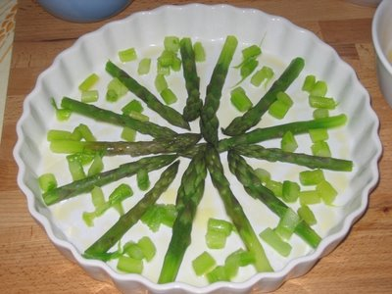
Put a few pieces of butter over the tips.
Add ham cut in stripes and sliced Fontina cheese.
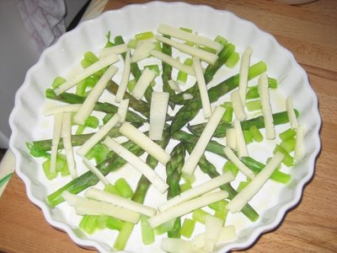
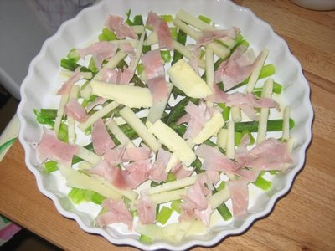
Whisk the eggs with a pinch of salt and grated Parmigiano (1-2 tblspoons). Pour the eggs over asparagus, cheese and ham,
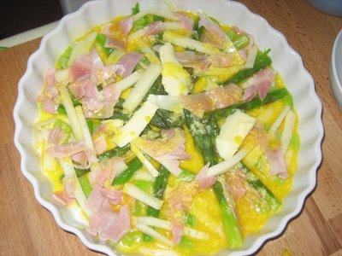
and bake for 10 minutes in a very hot oven (around 220°C) just until the eggs are set and the cheese starts melting.
I served this "frittata" with a mixed salad.
Buon appetito!
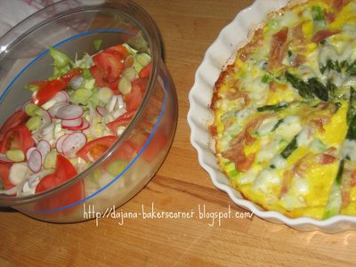
ASPARAGI AL FORNO
1/2 kg di asparagi
2 fette di prosciutto cotto
80 g di fontina
2 uova
Parmigiano Reggiano grattugiato
sale, burro
Lessate gli asparagi tenendoli molto al dente, sgocciolateli ed asciugateli.
Disponeteli in una pirofila leggermente imburrata con le punte verso il centro.
Sopra la parte tenera distribuite qualche pezzetto di burro, il prosciutto a striscioline e fettine sottili di fontina.
Versate poi le uova sbattute, salate e insaporite con un po' di formaggio grattugiato. Cuocete nel forno riscaldato a 220°C circa per 10 minuti.
ZAPEČENE ŠPAROGE
1/2 kg šparoga
2 kriške prešane kuhane šunke
80 g mekog sira (Fontina)
2 jajeta
ribani parmezan
sol, maslac
Operite šparoge, ogulite donji dio stapki, i kratko prokuhajte, ali da ostanu dosta čvrste. Ocijedite i osušite kuhinjskim papirom. Rasporedite šparoge u namaštenu vatrostalnu posudu tako da vrhovi budu okrenuti prema sredini. Rasporedite nekoliko komadića maslaca na mekane vrhove, pa preko njih stavite narezanu šunku i sir.
Umutite lagano jaja, malo posolite i pomiješajte s naribanim parmezanom. Prelijte preko šparoga, sira i šunke. Pecite u pećnici zagrijanoj na 220°C oko 10 minuta.
Dobar tek!

