ŠTRAMAC
nažalost o pravljenju štramaca našao sam samo na ovom francuskom sajtu, pa je dovoljno samo slike pogledati da vidite kako se to nekad radilo-Na svakom krevetu sa šušzama stavljao se vuneni štramac.
ht://designandwtpool.blogspot.com/2013/04/mattress-making.html
Wool mattress making Our experience making mattresses
Day 4 of the Master Class leads us down the road of a traditional technique of Wool Mattress making. The Class was hosted by Patrice Sebille, who enthusiastically imparted to us a world of Knowledge. He is a artesanal wool and spring mattress maker in Paris.
The process begins with two pieces of a strong cotton fabric, a stripe is best to use as it allows the artisan to ensure that the grain of the fabric is lining up correctly. This is important so that the strength of the weft is utilised fully ensuring the longevity of the mattress.
Etablissements Le Briandis the name of his company, installed since 1880 in the historical furnituremaker’s quarter of Paris. The label "EPV" (Entreprise du Patrimoine Vivant, Heritage Alive's Company), received in1996, and the "Trophée des Trésors Vivant de l'Artisanat" (the Living Craft maker Treasure Trophy) in 2012, is proof of his know-how.
A lucky chance has made him owner of "Etablissements Le Briand", which he saved from closing down.Since then, Patrice Sebille upholds tradition as much as contemporary innovation.
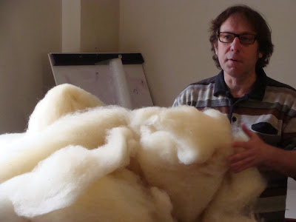
Patrice Sebille
The Process
Washed and carded wool is used to make the Mattress.In this Case we had wool that was not carded but we were able to pull it apart to create air and volume for the mattress.

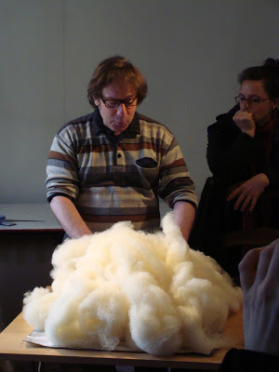
The Carded wool is built up in the mattress until it reaches a specific density, this density Is difficult to judge and is best learned through experience.
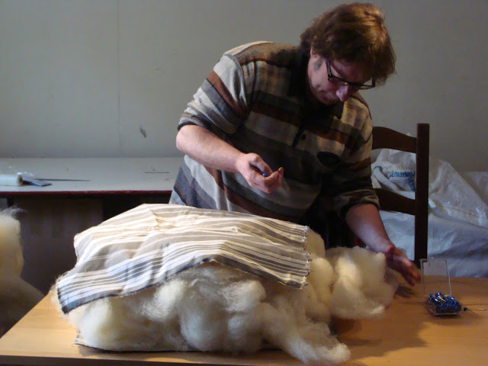
When the density of the wool is reached the second layer of cotton fabric is added on top and the stripes are lined up on each side and pinned into place.
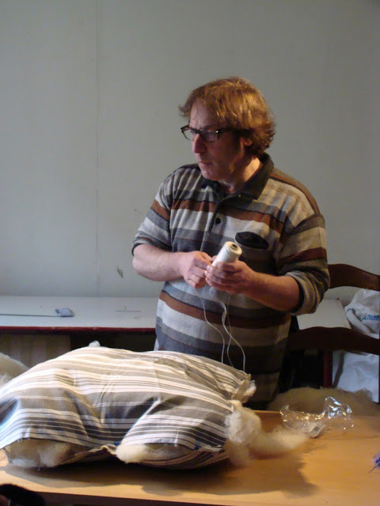
Now the edges are sewed together hiding the raw cut edges with a small single over sewing seam stitch, starting with the end where the stripes meet.
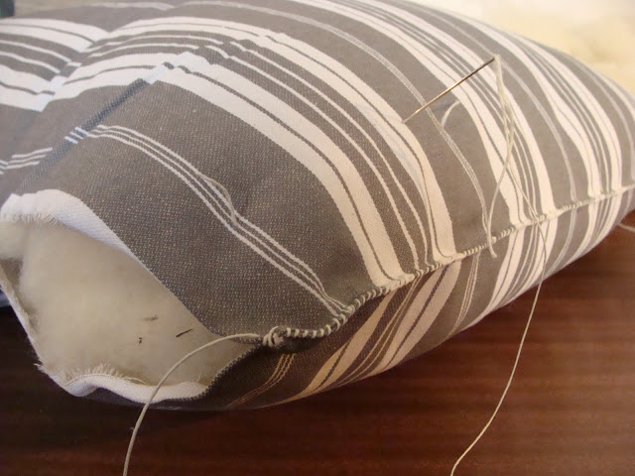
Once the edges are completely stitched around the four sides, the corners must be tucked in to create a boxed shape. Two rounds of stitching create a traditional roll around the circumference. giving the mattress a pronounced boxed shape. A large strong needle must be used to manipulate the wool inside the mattress to ensure the sides are full and packed with wool.
A special kind of knot (see above) must be used to start this stitching process of this roll.
The Final stage of the mattress making is adding the Buttons, these are far more than just a decorative effect. The process secures the wool in place to minimize movement within the mattress over time. It also compacts the wool creating a firm comfortable surface for an even distribution of weight.
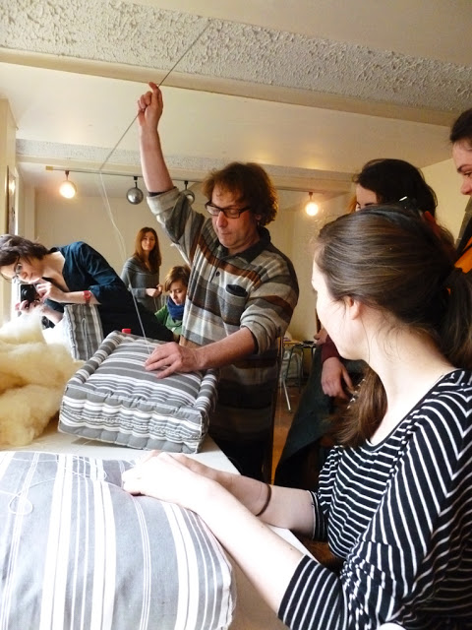
The needle must be long enough to travel through the mattress
Our mini mattresses:
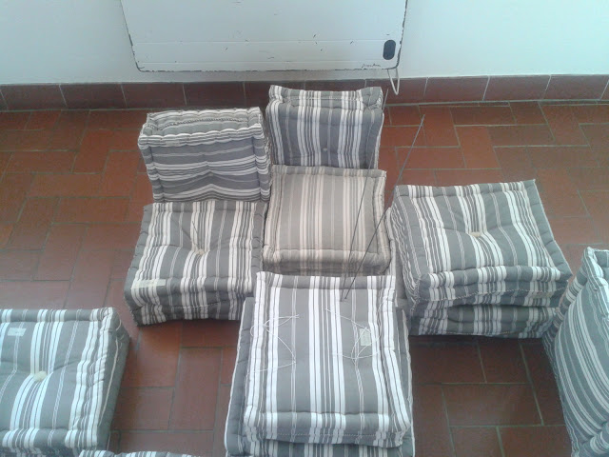

This is what a complete mattress looks like:

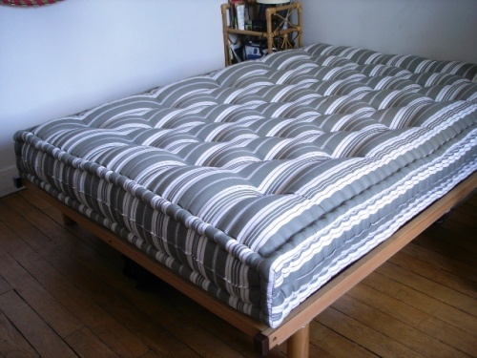

Applications of wool mattress techniques :
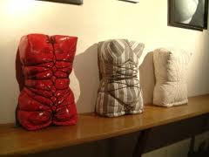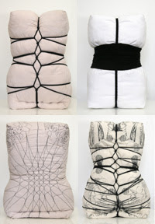

Textile Student Pauline Angotti's work as a result of Internship with Patrice Sebille
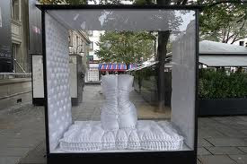
Pauline Angotti's Mattress Work for Shiseido

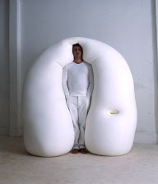
Ernesto Neto Biomorphic Sculpture
http://www.artbook.com/catalog--art--monographs--neto--ernesto.html

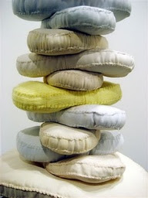
Louise Bourgeois 'Fabric Stack'

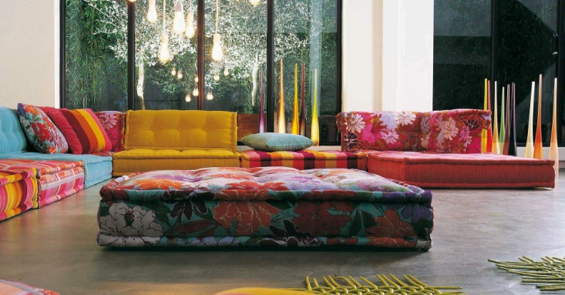
Roche Bobois Mah Jong modular sofa.

Layered mattresses sofa by Traffic

Wool Mattress Making Benefits From New Carding Machine
Oconomowoc Wisconsin

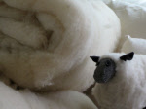 |  | The Wool Bed Company's  First Carding Machine
Adding this carding machine to bring more of the wool bedding production process in-house gives The Wool Bed Company even greater ability to ensure our Eco-Pure™ Wool mattresses, wool mattress toppers, wool pillows and other organic cotton bedding products meet our stringent standards of excellence. Processing tons of raw wool a month in house also helps the Wool Bed Company to lower costs and pass the savings on to our customers. A better quality wool bedding product at a better price is a win for the Wool Bed Company and for all our loyal customers who benefit from the comfort they receive from their organic wool mattresses and bedding.
You would think a substance which has been in use for hundreds of years would be fully appreciated, yet with all our technology, man has yet to make a mattress or bedding product which surpasses the comfort, support and safety (non-chemical fire resistance) of wool bedding products made with raw organic wool. To learn more about how organic wool bedding products are giving people a better night’s sleep than they ever dreamed of, read our testimonials, visit the Success Stories section of the website, or give the Wool Bed Company a call to learn how organic cotton/ Eco-Pure™ Wool bedding products can make your bed more comfortable.

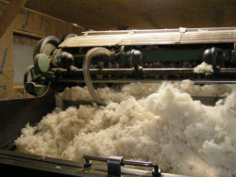 | 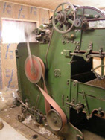 | 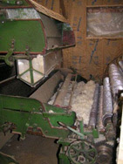
Step 1: Raw wool fibers for your organic mattress are place into the feeder of the carding machine where they are prepared for the carding process.  (Image 2) Side view of feeder processing raw fibers for our line of wool mattresses. |  | Step 2: After exiting the feeder, Wool mattress fibers are ready for processing by the carding machine nippers.

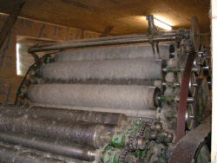 | 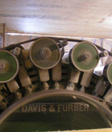 | 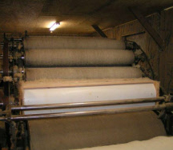
Step 3: The carding machine prepares the wool fibers for your Eco-Pure™ mattress by straightening and separating the wool fibers. The process begins with the worker rollers and stripper rollers pulling the fibers on and off the main cylinder also known as the swift. The swift carries the straightened fibers to the fancy and doffer rollers where the wool processing is finalized and ready to be made in a wool mattress, wool comforters, or an Eco-Pure™ Wool pillow.

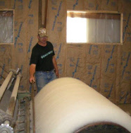 | 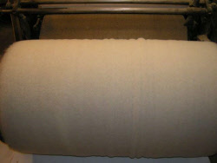 | 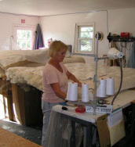
Final Steps: Before a wool mattress can be customized for you, the straightened wool fibers are rolled onto the batt drum and then stored ready to be made into a wool mattress, wool comforters, futon mattresses, or Eco-Pure™ Wool pillows. You will feel the benefits of a one of a kind organic mattress experience.

See Our Full Line of Wool Mattress and Wool Products

http://www.surroundewe.com/woolBedCompanyNews.asp?article=Wool+Mattress+Making+Benefits+From+New+Carding+Machine&aid=19&id=6

How to make a wool mattress
http://www.pinterest.com/daisymakes/how-to-make-a-wool-mattress/
coussin fr. (cushion en.)( cuscino it.) jastuk kušin

